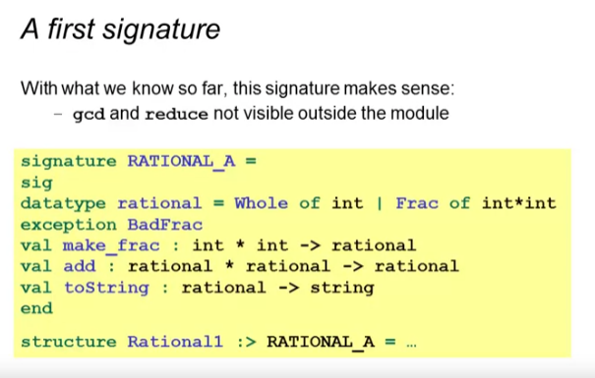

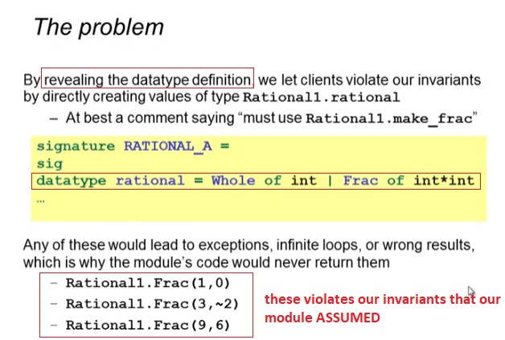

1st example using the revealed data type

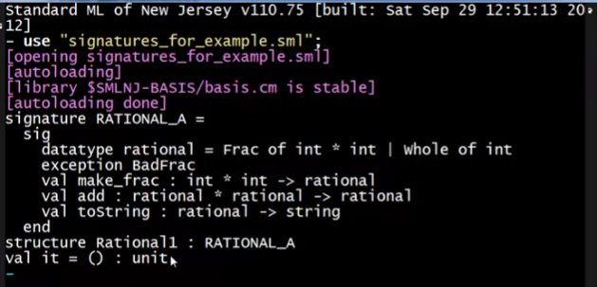

Doing correctly (calling make_frac)

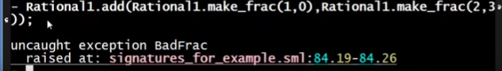

Doing wrong (calling the constructor Frac of int*int)

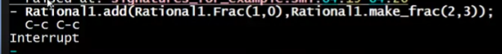

* Infinite loop – division by 0

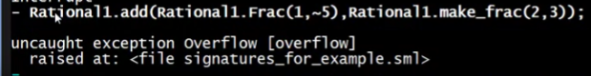

* Negative denominator – overflow



* Not reducing the value because Frac does not have reduce, only make_frac
* toString assumes that our value is already reduced

Intuition:

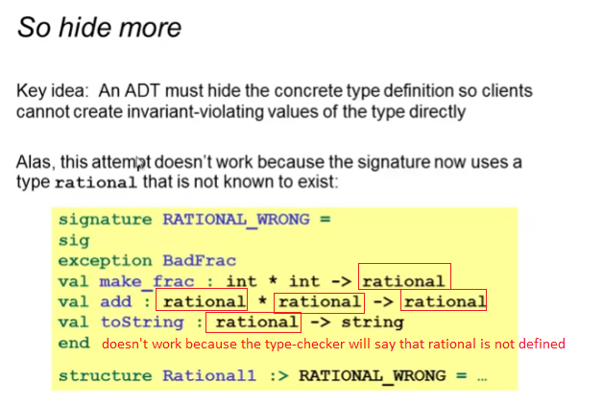

* we want to indicate to the type checker that yes rational is a type but I don’t want to display it
  + this is called an ABSTRACT type
    - type exists, but clients do not know its definition

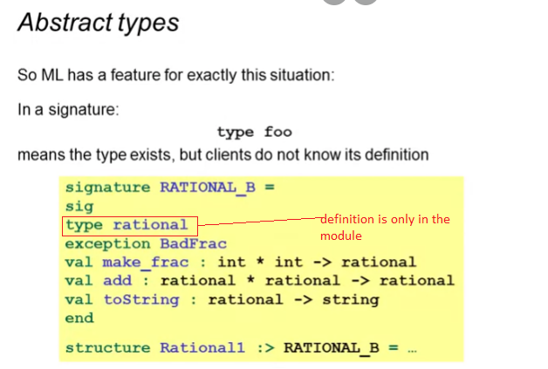

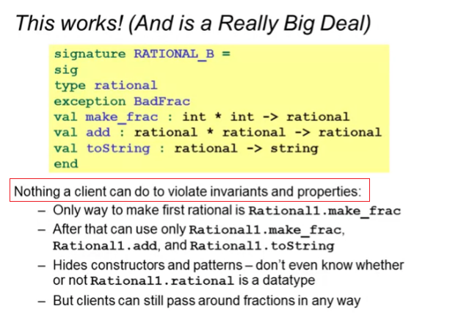

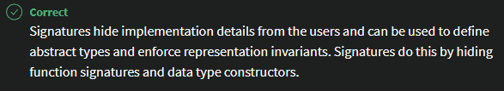

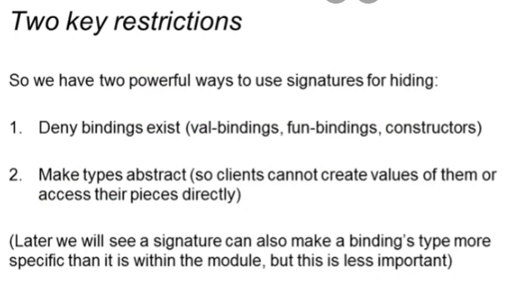

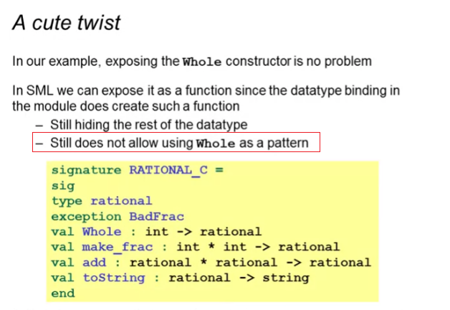

* this is good to simplify the calling of the clients from make_frac(12,1) to Whole(12)